FUNCTIONAL BEHAVIOR ASSESSMENT and EXECUTIVE FUNCTIONING EVALUATION

The Functional Behavior Assessment is designed to help understand a student’s behavior and to provide options in interventions when (1) behavior problems interfere with the student’s ability to learn, (2) behavior problems interfere with the learning of others, (3) the student is incapable of understanding or following the school rules, or (4) the student’s misconduct results in repeated removals from class.

DATA SOURCES:

 | Conduct grades from current and previous report cards
X | Discipline records (frequency and conduct)
X | Written documentation/classroom-based assessments produced by teachers and/or administrators
X | Observations provided by the classroom teacher and/or related services provider
X | Classroom observations by: |  | Korbin Williams, School Psychologist, BCBA
X | Behavior checklist
X | Evaluations provided by district: |  | FBA, completed by School Psychologist, BCBA
X | BIP developed on: |  | xx/xx/xxxx/
 | Information from student
X | Parent information
 | Information from outside agencies
X | Attendance
 | Other

BEHAVIOR PROBLEM(S) (in order of priority)

Targeted Behavior #1: Blurting out in class: blurting out is anytime that XXX calls out in class while a staff member or another peer is speaking, and he has not been called on to speak. This is often observed as XXX asking questions when the teacher is still speaking/teaching

Target behavior #2: Kicking/Hitting : Kicking/Hitting others is defined as anytime that the student makes contact with items (desk, walls, etc.) or others with his hands closed in a fist or his feet. This was not observed by the examiner but has been reported by the district.

Targeted Behavior #3: Elopement: Reports of elopement were noted by the district. This was observed by the examiner 1 time. Reports of elopement indicate that xxxx will run from staff members. XXX will exit the building between the buildings. When observed by the examiner xxxx eloped and went outside the glass doors between the buildings and sat down looking to see if anyone followed him.

Targeted Behavior #4: Refusal requiring removal of peers: District discipline referrals indicate that XXX has displayed behaviors in certain settings that required his peers to be removed from the classroom and at times restraints were reported. This behavior was not observed by the school psychologist despite challenging XXX with new interventions and even demands of compliance when he was frustrated.

Precipitating Conditions: Blurting was observed when XXX was working on the assignment at xxx’s desk and there were breaks in attention provided to him. While observing the examiner implemented non-contingent reinforcement on a 30 second interval and faded it to 2 minutes. While implementing this strategy blurting out reduced by 73% during the first observation and 80% during the second observation. His classroom teacher implemented verbal redirects with the promise of reinforcement (asking his question and her responding.) This would delay the question by the amount of time it took for her to finish the lesson but did not reduce the overall number of questions asked while his teacher was teaching. His teacher was also implementing a token economy. This token economy allowed XXX to earn tallies for working on and starting work. This was used to redirect him to the task with reinforcement happening after a certain amount of time.

Consequences: In all instances (100%) XXX was observed to receive some sort of attention for elopement, blurting or asking questions while the teacher was talking, or when in a refusal behavior, and a reduction in attention when not blurting out. 90% was redirected to a different behavior (attention), and 2% of times ignored (blurting out), 4% ignored when eloping, and 90% of elopements resulted in attention.

Function of the Behavior: The function of elopement is attention and escape/avoidance. The function of blurting out was to gain attention (clarification of questions). Hitting/kicking was hypothesized to be to escape a demand.

When is the student successful and therefore less likely to engage in this problem behavior? XXX is observed to be successful when he is regularly receiving attention, demands are reduced, and he is allowed to make some choices without being told what to do. He was the most successful when the intervention was a tally economy being presented prior to difficult tasks building the momentum of success.

Specific Assessment Techniques to be Used to Analyze this Behavior:
Observations were used as well behavior change techniques. These techniques are known as specific praise, DRA differential reinforcement of alternative behavior, and DRI differential reinforcement of incompatible behavior. DRA would be seen as providing reinforcement to XXX when he was complying with tasks and working and not providing any attention when he was not working. DRI would be seen when one provides reinforcement for a behavior that inhibits elopement, blurting out, or contacting peers or staff with hands or feet. (Example: Reinforce (provide tally when in line, sitting with hands to self, etc.) Using behavior momentum may seem over the top or unnecessary; however, when used in the general education classroom and other setting with the examiner it reduces the likelihood of XXX of elopement. The concept is to slowly build up to the difficulty of the student’s compliance by building confidence and use of desirable behaviors.

Important factors observed:

All staff members working with XXX implemented strategies to prevent his behavior; however, he was able to escape demands in 90% of opportunities during which he attempted to hit, kick, or elope. In 100% of opportunities that the examiner would maintain the demand, while promising reinforcement, XXX would eventually comply with the tasks.

DATA RELATED TO THE BEHAVIOR

FIGURE 1 OF 2

FIGURE 2 OF 2
Executive Functioning

The Delis Rating of Executive Function (D-REF) is used in assessing possible executive functioning deficits. The intention of looking into the executive functioning of students is to better understand areas that may cause stress or lead to behavior. XXX’s XXX and his classroom teacher both completed the D-REF which provided us with a better understanding of observed stressors both in the home in the classroom. The teacher report indicates a higher concern with executive functioning and behavior; however, both the teacher and the parent scales provided elevated scores in executive functioning.

Executive function and self-regulation skills are the mental processes that enable us to plan, focus attention, remember instructions, and juggle multiple tasks successfully. Just as an air traffic control system at a busy airport safely manages the arrivals and departures of many aircraft on multiple runways, the brain needs this skill set to filter distractions, prioritize tasks, set and achieve goals, and control impulses.

When children have opportunities to develop executive function and self-regulation skills, individuals and society experience lifelong benefits. These skills are crucial for learning and development. They also enable positive behavior and allow us to make healthy choices for ourselves and our families.

Executive function and self-regulation skills depend on three types of brain function: working memory, mental flexibility, and self-control. These functions are highly interrelated, and the successful application of executive function skills requires them to operate in coordination with each other.

- Working memory governs our ability to retain and manipulate distinct pieces of information over short periods of time.
- Mental flexibility helps us to sustain or shift attention in response to different demands or to apply different rules in different settings.
- Self-control enables us to set priorities and resist impulsive actions or responses.
- Source: )https://developingchild.harvard.edu/science/key-concepts/executive-function/)

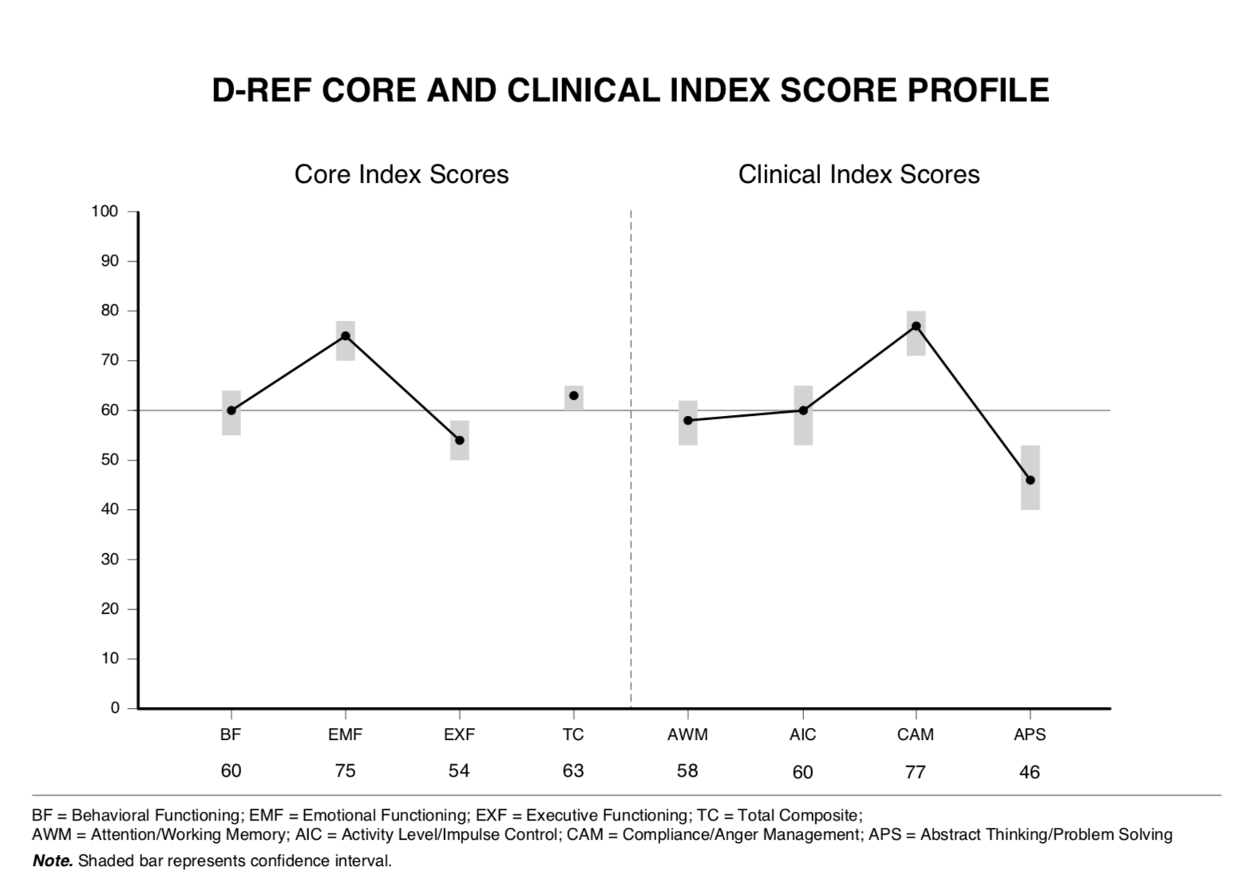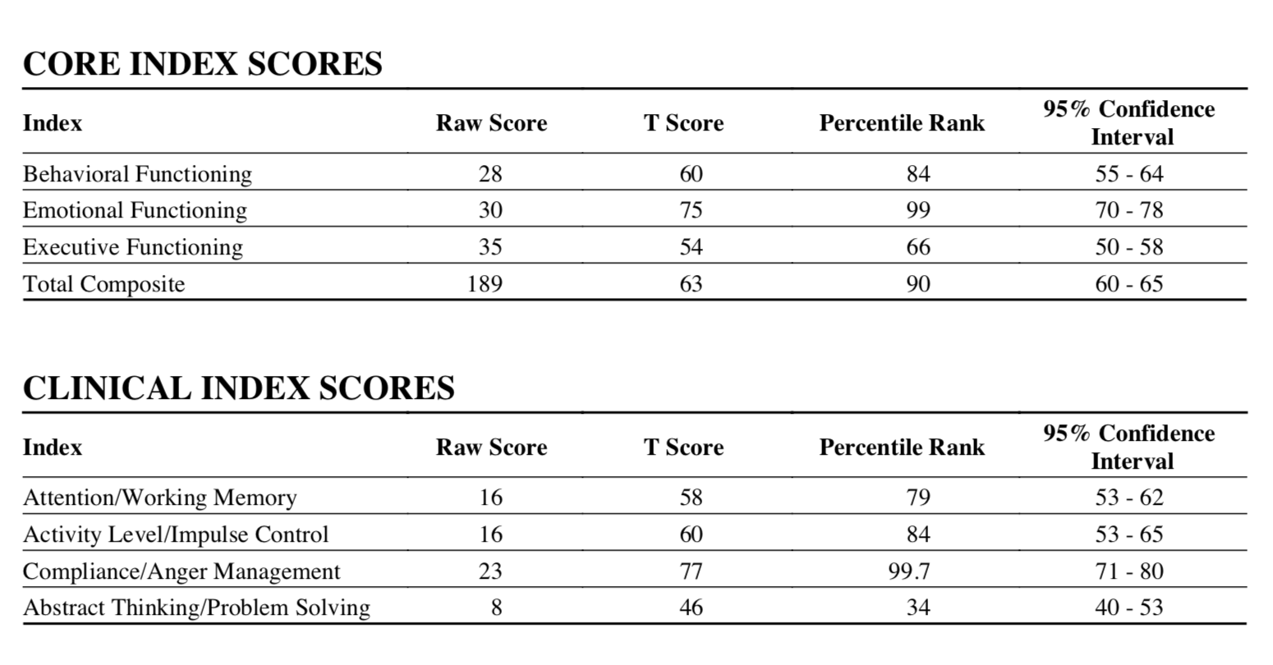
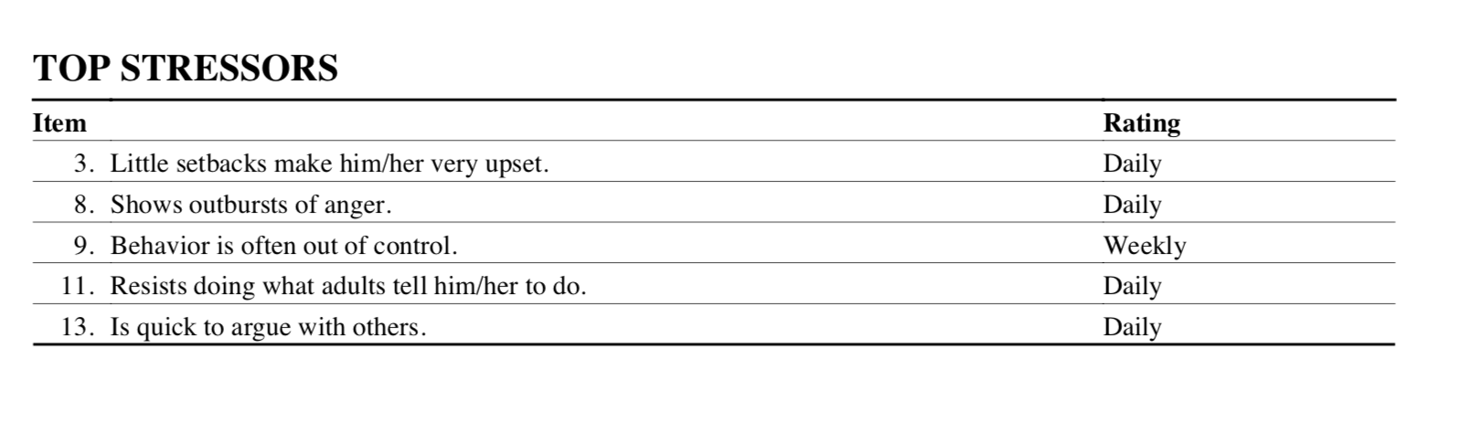
Parent Report
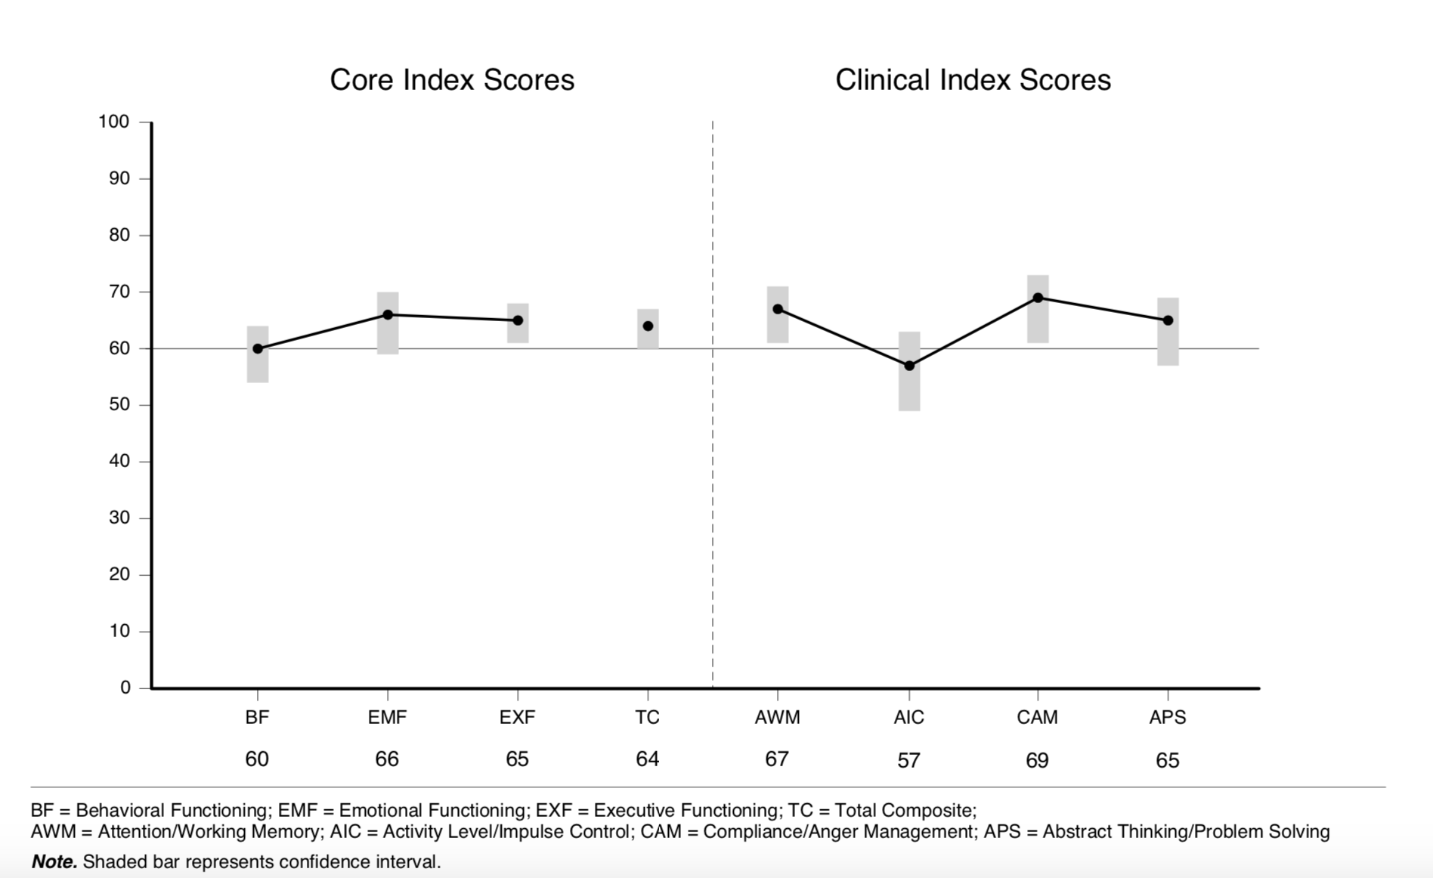

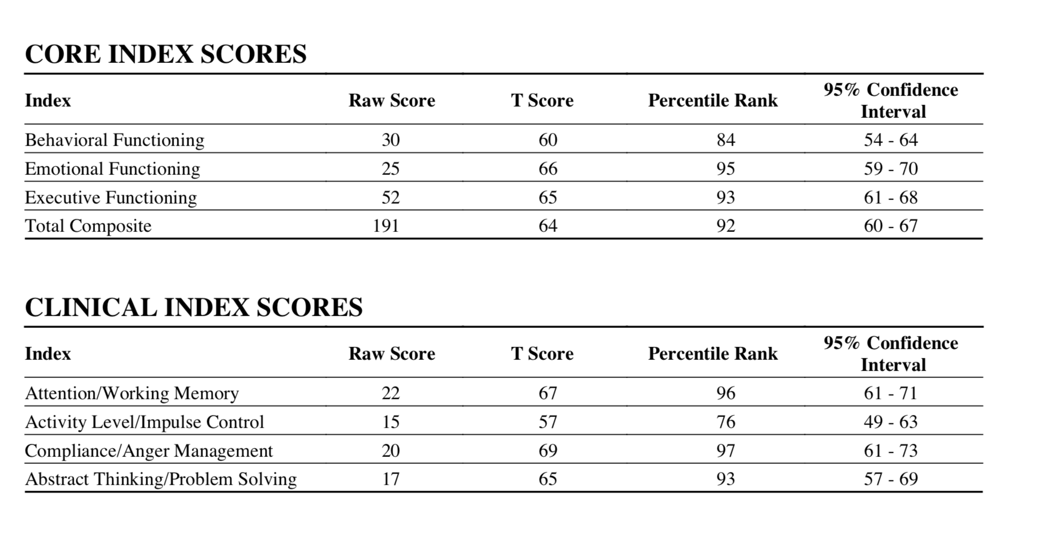
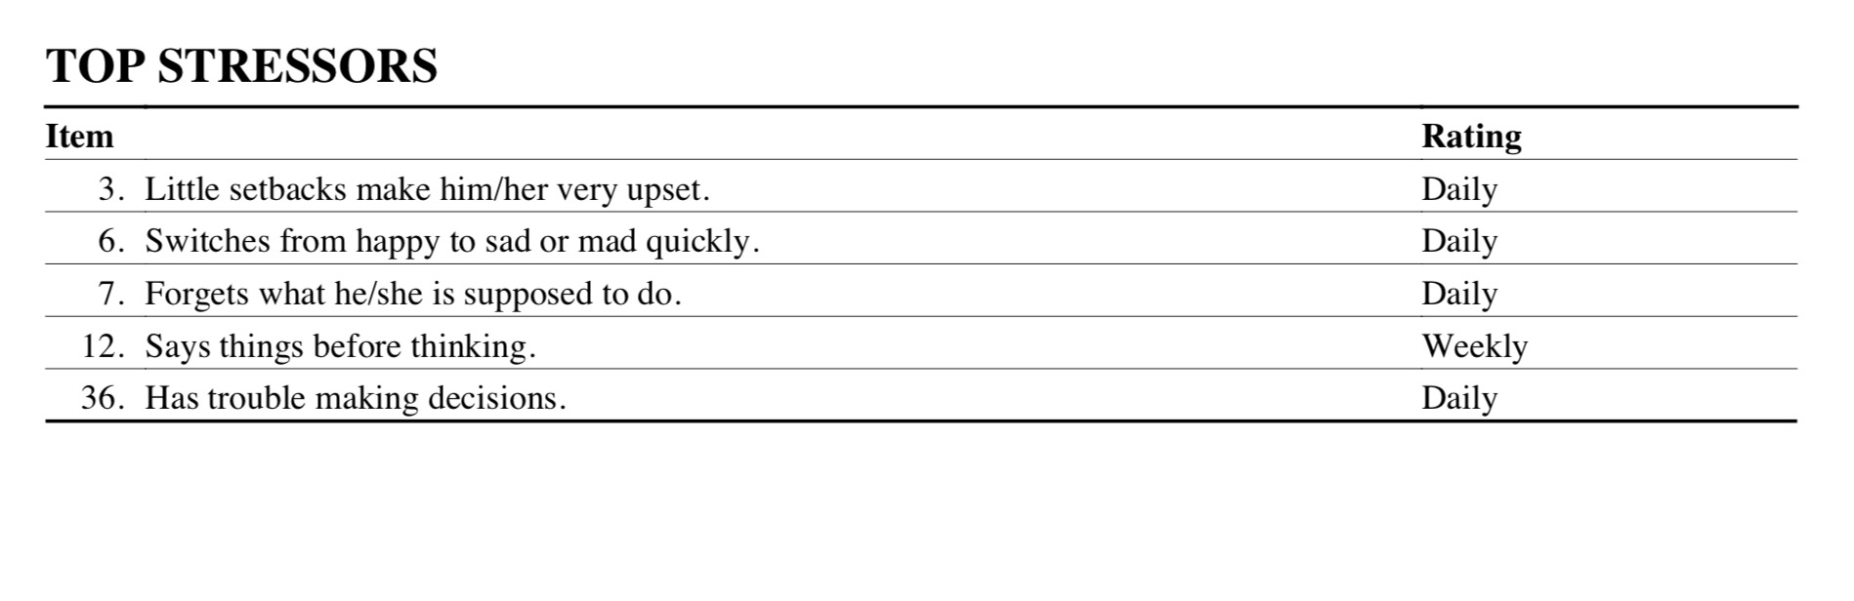
Summary

Reports from both the school and from his parent indicate that XXX’s executive functioning is still developing and requires more support to support that functioning. Currently the school is implementing social skills training, token economies, and training to develop his executive functioning further. As stated above executive functioning is directly related to mental flexibility, self-control, and working memory. Building these skills can take place using social stories, behavior training, video modeling, and re-teaching,

Recommendations:

- Providing support in the school setting and home with teaching skills needed. “Think, stop, count.” “Tell us how we can help you.”

- Growth-promoting environments provide children with “scaffolding” that helps them practice necessary skills before they must perform them alone. (Basically, form a ladder of steps. Start at the bottom and build skills from there.)

- Adults can facilitate the development of a child’s executive function skills by establishing routines, modeling social behavior, and creating and maintaining supportive, reliable relationships.

- It is also important for children to exercise their developing skills through activities that foster creative play and social connection, teach them how to cope with stress, involve vigorous exercise, and over time, provide opportunities for directing their own actions with decreasing adult supervision.

A BEHAVIOR INTERVENTION PLAN IS RECOMMENDED AND IS ATTACHED TO THIS REPORT.

BEHAVIOR INTERVENTION PLAN

Behaviors:  What is the behavior that needs to be changed? | ELOPEMENT: Anytime that XXX runs, walks, skips, away from staff or walks out of the doors away from everyone.
Prevention Techniques:  What strategies will be implemented to prevent the inappropriate behavior from occurring? | XXX presents with visible and audible signs of frustration. When these are observed begin to use behavior momentum to direct XXX to a new task, distraction him, building up a successful behavior. Use a faster intervention schedule. Provide more reinforcement for the simplest compliance.  “I like how you are standing up! You earned your tally!”  REDUCE DEMANDS.
Replacement Behavior:  What appropriate behavior will be targeted to replace the inappropriate behavior? | Currently it is important to provide XXX with a behavior to replace elopement. This can be done by teaching where to go, how to leave, and how to request a break.
Teaching Strategies:  What methods will be used to teach the student the appropriate replacement behavior? | Modeling: Providing examples by modeling the behavior.  Prompting  Reminders: Remind of behavior we want. “Great job leading the class.” “Thank you for helping me by watching from the back of the line.”  Schedules: Prep for any schedule changes  Teaching what to do instead of elopement.
Reinforcement Strategies:  What techniques will be used to reinforce the occurrence of the replacement behavior? | Provide reinforcement for the desired behavior, reduce academic rigor of the assignments (this means using momentum or if a concept has clearly been mastered reduce the number of repetitive questions not to take down the level of the assignment), reduce demands and instruction, allow for XXX to make more choices independently, allowing breaks for completing specific amounts of work or simply reminding him of where he can go if he is frustrated. Also, at times just sit and allow him to redirect on his own. He has shown the ability to redirect his own behavior. Trust the process and allow him to do this while not providing demands.
Consequence:  What will be the consequence for the student engaging in this inappropriate behavior? | XXX’s consequences to start should be to hold the demand of telling someone he is frustrated and going to an appropriate place. Reduce the opportunity to escape the task that he eloped from. Make sure that the demands that are placed are promoting desirable behaviors not behaviors we do not want. Reinforce his self-redirect.  Allow him to become calm and then place the request for him to go back to where he was, complete the tasks, earn tokens, and then move back to the area of elopement.

Behavior #2:  What is the behavior that needs to be changed? | Hitting/kicking: Any time that XXX makes intentional physical contact with staff with hands, feet, fists, elbow etc.
Prevention Techniques:  What strategies will be implemented to prevent the inappropriate behavior from occurring? | When the student is about to be assigned or asked to complete a task, he does not like provide him with slow gradual steps to get to that task. USE THE TOKEN ECONOMY with a high rate of reinforcement PRIOR TO THE ASSIGNMENT. This is known as behavioral momentum. “XXX here is a token you earned more time!” This was shown to reduce the likelihood of behavior during the assessment. It is important that all staff members use the same interventions and not “use their own.” USE THEM AS TESTED.
Replacement Behavior:  What appropriate behavior will be targeted to replace the inappropriate behavior? | At this time, it is important to provide XXX with a behavior to replace hitting, kicking, and other refusals. This can be done by teaching him how to hand a “no” card, requesting to leave, verbally expressing frustration, or simply calm counting. Praise the behaviors when he is calm or redirecting. We do not want to say, “calm down.” We want to say, great job using your inside voice.” “Great job keeping your feet on the ground.” “Tally for sitting there so quietly.”
Teaching Strategies:  What methods will be used to teach the student the appropriate replacement behavior? | Modeling  Prompting  Reminders  Schedules
Reinforcement Strategies:  What techniques will be used to reinforce the occurrence of the replacement behavior? | Provide reinforcement for the desired behavior, reduce academic rigor of the assignments, reduce demands and instruction, allow for XXX to make more choices independently, allowing breaks for completing specific amounts of work. Reinforce at a high rate prior to the tasks. We want to increase the likelihood of success, starting off assignments, and completion without other aggressive behaviors.
Consequence:  What will be the consequence for the student engaging in this inappropriate behavior? | When XXX does hit at, kick at, or other refusal behaviors it is important to know the appropriate action. Correct him and then begin to ignore him. IF the behavior leaves the student in jeopardy of being hurt or hurting others IGNORING IS NOT APPROPRIATE. Use reinforcement strategies first, “XXX, great job keeping your feet on the ground.” (Reinforce desirable behavior not focusing the non-desirable). Next, staff should place themselves in a safe position creating distance between them and the student. This is only an example, and the strategy will change regularly. It is important to adapt with behavior. At other times staff should sit in a safe place reducing demands to 0 and allowing him to calm without demands.

Behavior #3:  What is the behavior that needs to be changed? | Blurting out: Any time that XXX calls out/speaks out during the lesson while a staff member teaching a lesson or responding to another student and XXX has not been called on.
Prevention Techniques:  What strategies will be implemented to prevent the inappropriate behavior from occurring? | XXX calls out in class when he has not received attention within 5 minutes of the blurting behavior. Staff should implement noncontingent reinforcement with XXX. Start with every 30 seconds and then slowly fade to every 4-5 minutes.  Option 1: Offer XXX question cards/sticks/tickets with a set maximum for the day/period. This would start with several and slowly fade as blurting out is reduced.  Option 2: Provide XXX the opportunity to ask questions at a certain time. If he is worried that he may forget the question allow him to record the question on a recording device. (This may need a timer or limit of questions but needs to be set with him knowing the limits of the questions).  A time can then be set for him to listen to the questions and ask the teacher, use the computer to look them up, or similar. Allowing him to find the answer while building his independence to discover the answers without interrupting the class.  Option 3: Form a combination of the options above that meet the class schedule while also allowing XXX to feel success in finding answers to these questions.
Replacement Behavior:  What appropriate behavior will be targeted to replace the inappropriate behavior? | Currently it is important to provide XXX with a behavior to replace blurting out. This can be done by teaching him how to place a question card in a container to be answered after the lesson, marking a question mark or similar. Start with a high number of tickets than slowly fade them as the week goes on.  Option 1: Offer XXX question cards/sticks/tickets with a set maximum for the day/period. This would start with several and slowly fade as blurting out is reduced.  Option 2: Provide XXX the opportunity to ask questions at a certain time. If he is worried that he may forget the question allow him to record the question on a recording device. (This may need a timer or limit of questions but needs to be set with him knowing the limits of the questions).  A time can then be set for him to listen to the questions and ask the teacher, use the computer to look them up, or similar. Allowing him to find the answer while building his independence to discover the answers without interrupting the class.  Option 3: Form a combination of the options above that meet the class schedule while also allowing XXX to feel success in finding answers to these questions.
Teaching Strategies:  What methods will be used to teach the student the appropriate replacement behavior? | Modeling  Prompting  Reminders  Schedules  Teaching what to do instead of blurting out.
Reinforcement Strategies:  What techniques will be used to reinforce the occurrence of the replacement behavior? | Provide reinforcement for the desired behavior, reduce academic rigor of the assignments, reduce demands and instruction, allow for XXX to make more choices independently, allowing breaks for completing specific amounts of work. Reinforce when he does not blurt out. Praise him, allow extra breaks for not blurting out.
Consequence:  What will be the consequence for the student engaging in this inappropriate behavior? | When XXX does blurt out remind him about the token economy and how to ask questions, place the cards in the box, where the recorder is, or even offer for him to look the question up on his own after recording the question.

DRAFT GOAL:

Goal: By the end of the school year XXX will build independence in the school setting, reducing the need for teacher/staff redirects, by recognizing and tracking his own behavior, by independent implementation of his token economy, in 5 out of 10 opportunities as measured by tracking each time he independently implements the token economy. XXX will first be taught how to track his own behavior and tokens/tallies.

Objective 1: XXX will build independence in the school setting, reducing the need for teacher/staff redirects, by recognizing and tracking his behavior, by independent implementation of his token economy, in 4 out of 10 opportunities.

Objective 2: XXX will build independence in the school setting, reducing the need for teacher/staff redirects, by recognizing and tracking his behavior, by independent implementation of his token economy, in 3 out of 10 opportunities.

Objective 3: XXX will build independence in the school setting, reducing the need for teacher/staff redirects, by recognizing and tracking his behavior, by independent implementation of his token economy, in 2 out of 10 opportunities.

Baseline data for behavior:

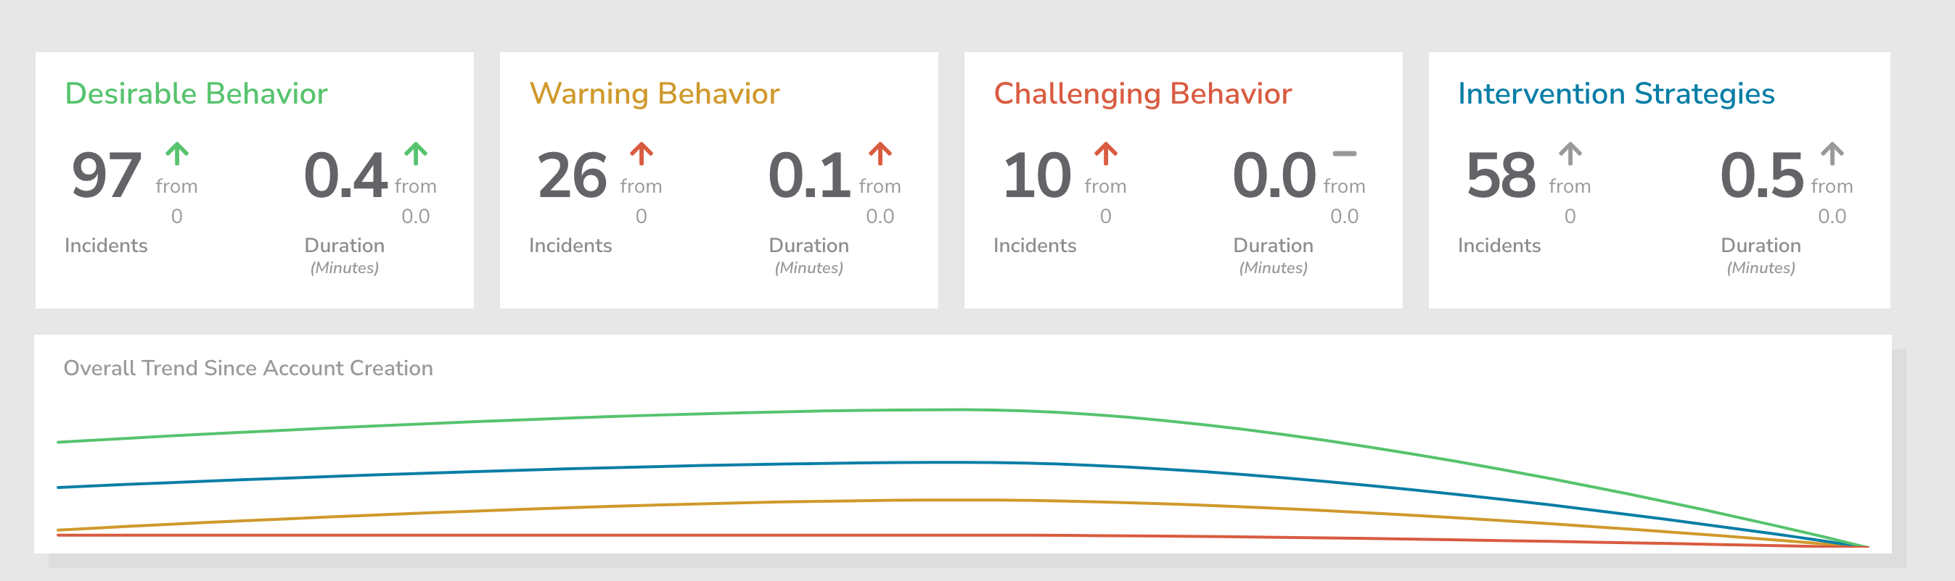

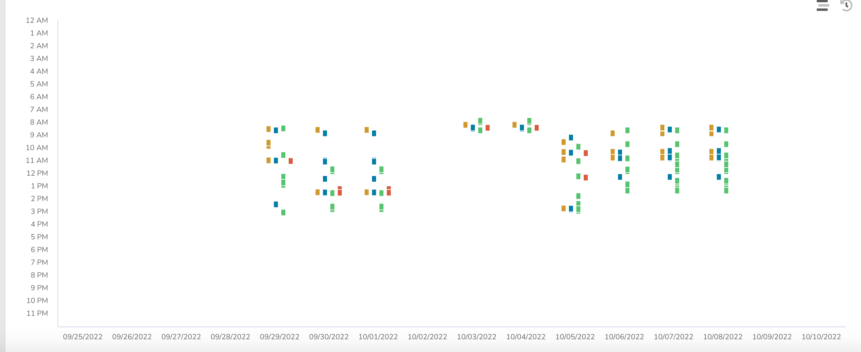

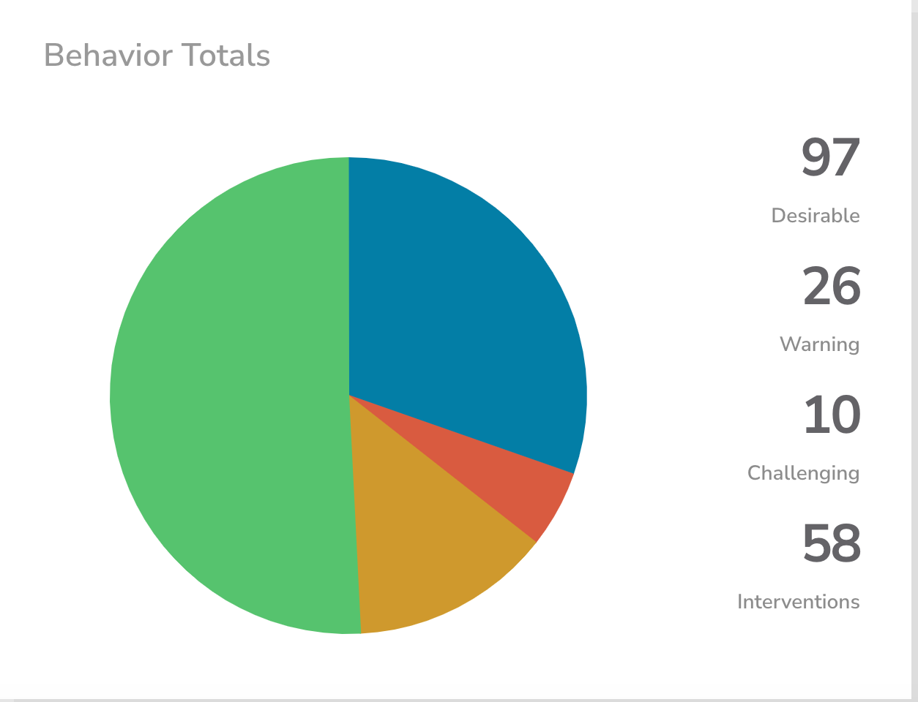

LINKS:

- Token Economy:
  - https://www.verywellfamily.com/create-a-token-economy-system-to-improve-child-behavior-1094888
  - https://aba-works.com/6-best-steps-to-set-up-a-token-economy/

- Behavior Momentum:
  - https://www.unl.edu/asdnetwork/virtual-strategies/behavior-momentum
  - (ABOVE CONTAINS A VIDEO LINK)
  - https://youtu.be/vmLhearDw-M
  - https://www.youtube.com/watch?v=eryaiphLtiM
- Modeling:
  - https://www.ifioque.com/social-psychology/Modeling_of_Behavior
  - https://www.verywellmind.com/social-learning-theory-2795074

- Prompting:
  - https://youtu.be/Q-UEvOOTw7Y
  - https://youtu.be/4XYA8k41iLU

- Schedules:
  - https://youtu.be/GfjmXbDGpyI

Behavior intervention learning opportunities:

https://masteraba.com/understanding-consequence-interventions-punishment-vs-reinforcement/

